Multi-model
# Source: AI Source: Provided by: [Data Path: Persons Table -> ID Column: 1, Name_En Column: Motasem Essam] -> From: [ChatGPT] on [6/10/2026]
A multi-model database is a database that supports multiple types of data models—instead of just one like traditional relational databases.

🧠 In Simple Terms:
# Source: AI Source: Provided by: [Data Path: Persons Table -> ID Column: 1, Name_En Column: Motasem Essam] -> From: [ChatGPT] on [6/10/2026]
Instead of being just relational (tables with rows & columns), a multi-model database can also handle:
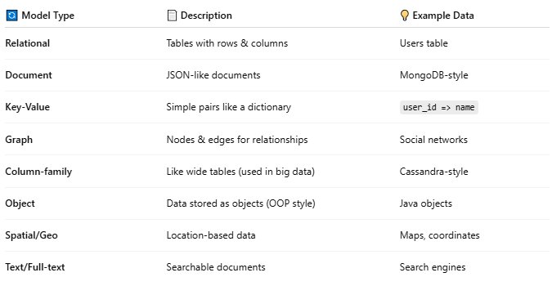
🔄 Model Type | 📄 Description | 💡 Example Data
Relational | Tables with rows & columns | Users table
Document | JSON-like documents | MongoDB-style
Key-Value | Simple pairs like a dictionary | user_id => name
Graph | Nodes & edges for relationships | Social networks
Column-family | Like wide tables (used in big data) | Cassandra-style
Object | Data stored as objects (OOP style) | Java objects
Spatial/Geo | Location-based data | Maps, coordinates
Text/Full-text | Searchable documents | Search engines

📦 Example: Oracle, PostgreSQL, and Couchbase
# Source: AI Source: Provided by: [Data Path: Persons Table -> ID Column: 1, Name_En Column: Motasem Essam] -> From: [ChatGPT] on [6/10/2026]
- Oracle supports:
  - Relational + Document (JSON) + Graph + Spatial + XML
- PostgreSQL supports:
  - Relational + JSON + Key-Value + Graph (via extensions)
- Couchbase / ArangoDB:
  - Designed natively for multi-model

🏁 Why Multi-Model Matters:
# Source: AI Source: Provided by: [Data Path: Persons Table -> ID Column: 1, Name_En Column: Motasem Essam] -> From: [ChatGPT] on [6/10/2026]
- 🔗 Less need to integrate multiple databases
- 🚀 Faster development with mixed data types
- 🧩 Flexibility to use best model for each task

